At the Pendleton Unmanned Aerial Systems Range, I pursued a personal project in my free time, building a FPV drone **(Figure 1)** under the guidance of my supervisor (Range Chief Engineer, Steve Lawn).

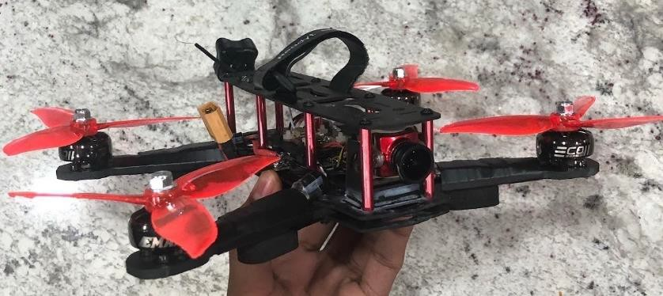

**Figure 1:** Completed FPV Drone

* 1. Using a carbon fiber frame, I mounted 4 motors and soldered each motor to an electronic speed controller (ESC). Each ESC’s power and signal wire were soldered to an all-in-one flight controller (AIO FC) which acted as both a power distribution board (PDB) as well as a flight controller **(Figure 2)**.

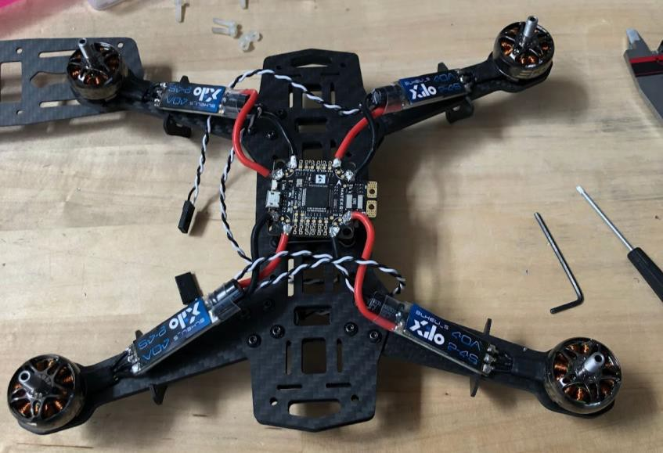

**Figure 2:** Drone Motor/ESC/AIO FC Wiring

* 1. Using CAD, I designed, and 3D printed a mounting board to stack the video transmitter (VTX) atop the AIO FC. I soldered cables to connect the video out pin on the AIO FC to the video pin on the VTX and connect the 5-volt out pin on the AIO FC to the 5-volt in pin on the VTX to provide power to the board **(Figure 3)**.

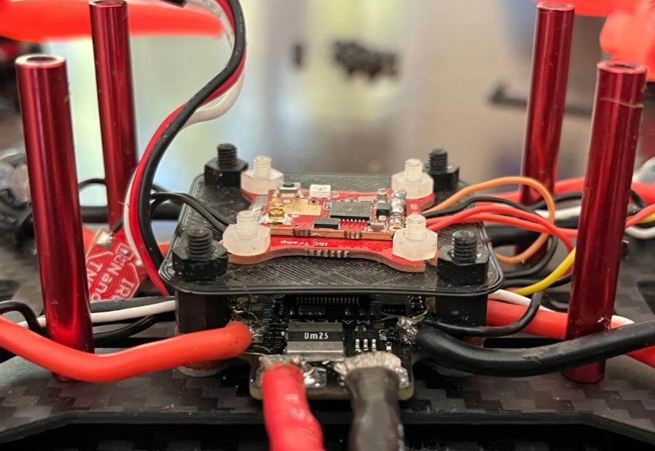

**Figure 3:** VTX Wiring

* 1. I then soldered cables between the 5-volt out pin on the VTX and the 5-volt pin on the camera to power it. I also connected the camera’s video cable to the video IN pin on the AIO FC **(Figure 4)**.

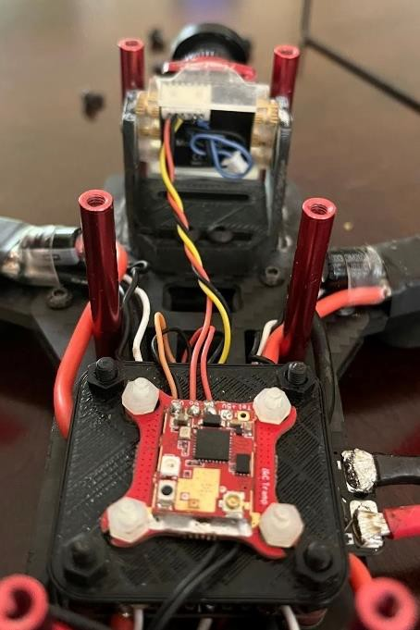

**Figure 4:** VTX to Camera Wiring

* 1. To mount the camera to the frame, I used CAD to model and 3D print a bracket that housed the camera **(Figure 5)**.

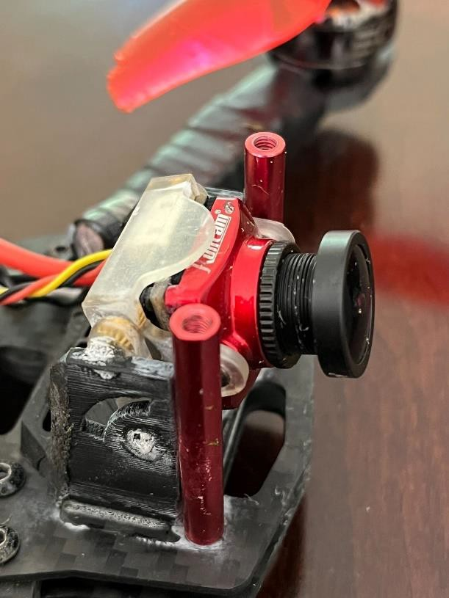

**Figure 5:** CAD Modeled Camera Bracket, 3D Printed and Superglued to Frame

* 1. I mounted the antenna connector to the frame’s cover and screwed the right-hand circular polarized antenna into the connector **(Figure 6)**.
  2. An FrSky receiver was necessary to enable a connection between the transmitter and the drone. I wired power to the receiver and routed its signal cable to the AIO FC **(Figure 6)**.

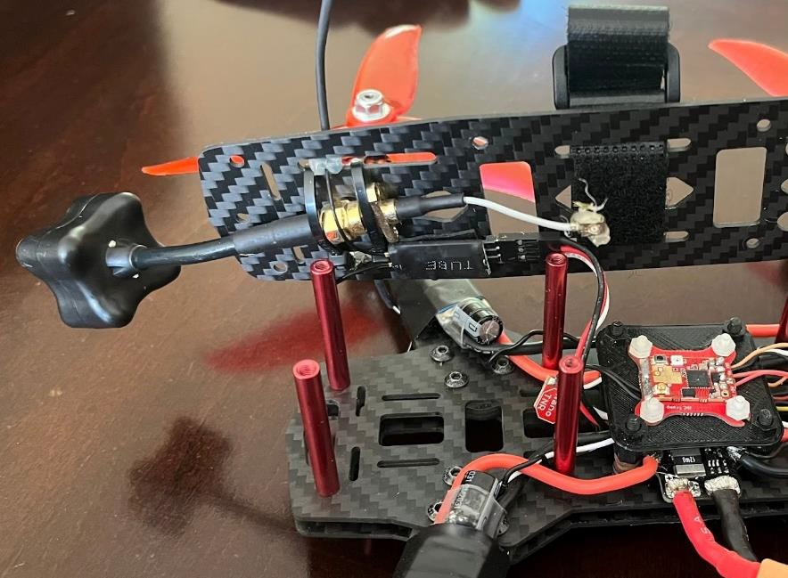

**Figure 6:** Transmitter Wired to AIO FC, Antenna Mounted to Frame Cover

* 1. Finally, I hooked up an XT60 connector to the main power pads of the AIO FC

# (Figure 7).

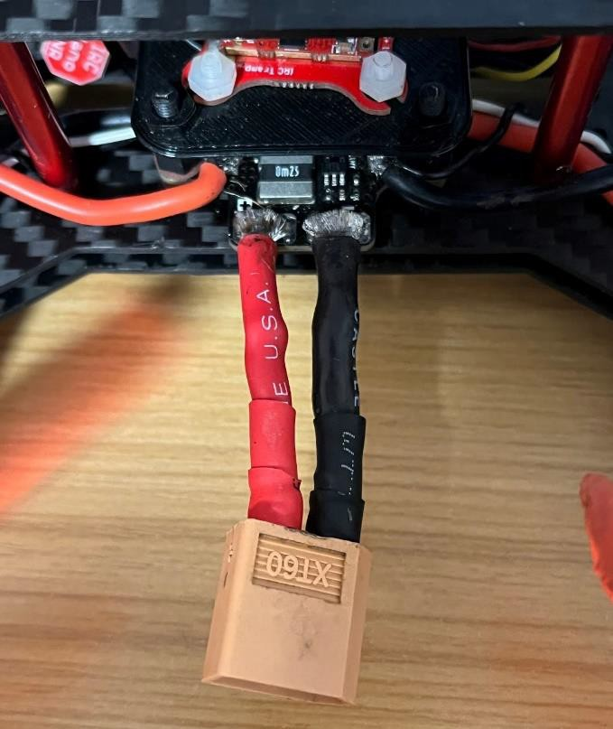

**Figure 7:** XT60 Connector Wired to AIO FC

**Clip 1** captures the initial power on of the FPV drone, and **Clip 2** shows flight footage.

This project was rewarding as I was able to learn by doing. I learned more about circuits by looking at pinout diagrams and wiring them. I also was able to expand my shop skills and continue refining my CAD skills. This initial project has turned into a passion for me and I actively fly FPV drones in my free time.